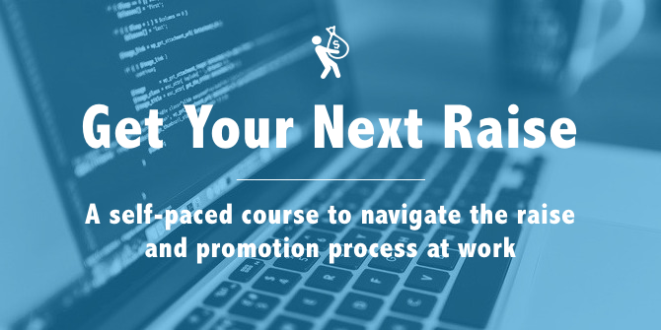

Get Your Next Raise worksheet

Learn more about Get Your Next Raise:

https://fearlesssalarynegotiation.com/get-your-next-raise/

Use this worksheet as you work through the course so you have one place with your research, goals, action items and results.

Estimate your market value and Set your goal

My market value estimation: ___________
My target salary: ___________

Build your case

Examples of accomplishments that focus on a quantitative result

- “Actively managed four concurrent projects (up from three), bringing an additional $20,000 in revenue this year.”
- “Took control of the new project assignment process from Tiffany, saving her about two hours a week.”
- “Configured a more resilient IT setup, making failure less likely and recovery easier, saving 40 hours per recovery.”

Accomplishments [replace each bullet with an accomplishment of your own]

- Activity result
- Activity result
- Activity result
- Activity result
- Activity result

Examples of accomplishments that focus on a quantitative result

- “Alison introduced a new time tracking tool that saves every Project Manager about three hours a week in administrative time. This has saved our team over a hundred hours so far this year.”—Christina Smith, PMO Director
- Spotlight Award—For working three straight weekends on pre-sales for the ACME Corp deal to close it before end of year, bringing in an additional $15,000 in revenue for 2014.
Accolades [replace each bullet with an accolade of your own]

- Client or co-worker name—“Quote” or general feedback documented in email or survey
- Client or co-worker name—“Quote” or general feedback documented in email or survey
- Client or co-worker name—“Quote” or general feedback documented in email or survey

Put your case in writing
Draft the email you will send to your manager after your verbal discussion.

To: [Your manager’s email address]
Subject: [Your name] salary adjustment discussion—follow-up
Hi [Your manager’s name]
Thanks for your time the other day. As we discussed, it has been [amount of time] since [“my last significant salary adjustment” OR “since I was hired”], and I would like to revisit my salary now that I’m contributing much more to the company. I’ve been researching salaries for [job title] in [industry] industry, and it looks like the mid-point is around [mid-point from your research]. So I would like to request a raise to [target salary].
I’ve been working very hard to find ways to contribute value to our company. Here are some of my accomplishments over the past several months:
- Activity result
- Activity result
- Activity result
- Activity result
And here is some feedback I’ve received from clients and co-workers over the past several months—their feedback speaks louder than anything I could say:
- Client or co-worker name—“Quote” or general feedback documented in email or survey
- Client or co-worker name—“Quote” or general feedback documented in email or survey
- Client or co-worker name—“Quote” or general feedback documented in email or survey
I believe these accomplishments and feedback show that my work merits a higher salary, and [target salary] seems well aligned to the current market and with the additional value I am adding to our company since my current salary was set. I look forward to hearing what I can do to help make this happen.
Thanks again for your time and consideration!
All the best
[Your name]
Plan your next steps
For each of the three common outcomes to your raise request, plan your next steps.

Not yet

My plan and timeline to achieve this goal:

No

Other jobs I could consider at my current company:

Other jobs I could consider in other companies or industries:

Yes

My next goal—target salary or target job:

